Dr. Mamdouh A. Eissa | 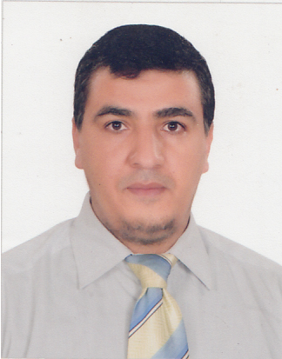

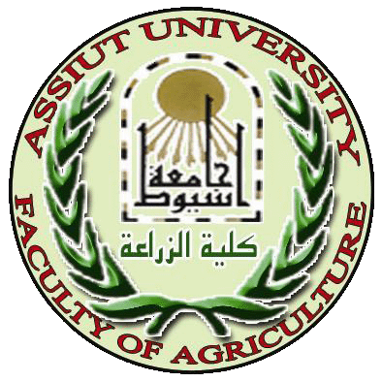

Assiut University Faculty of Agriculture

Date of birth: October 15th, 1977 Place of birth: Sohage, Egypt Citizenship: Egyptian Marital status: Married

Academic field: Agriculture
Major: Soil and Water
Minor: Plant nutrition and soil fertility, Irrigation, Environmental pollution, Halophyte plants

Address: Department of Soils and Water, Faculty of Agriculture, Assiut
University, Assiut, 71526, Egypt, email: mamdouhessa@gmail.com
mamdouh.eissa@agr.au.edu.eg
Tel: +20 100 3378637
Researchgate site: https://www.researchgate.net/profile/Mamdouh_Eissa4
Google scholar site: https://scholar.google.com/citations?user=qSkwrQQAAAAJ&hl=en
Assiut University site: http://www.aun.edu.eg/arabic/membercv.php?M_ID=1325

Education:
B.S. : Soil science, 2000, Assiut University (First-class honours) .
M.Sc.: Soil science (Irrigation and Soil fertility), 2007, Assiut University.
Ph.D.: Soil science (Bioremediation), 2012, Assiut University.

Title position:
2002-2007: Demonstrator in Soils and Water department, Assiut University.
2007-2012: Assistant lecturer in Soils and Water department, Assiut University.
2012-present: Lecturer in Soils and Water department, Assiut University.
2012-present: Technical supervisor of central laboratory of Assiut University.

Team member of the following projects:
- 2011-2014. Heavy Metals: Pollution and Remediation in Soils of Assiut, Egypt. Science and Technology Development Fund (STDF).
- 2012-2015. Establishment of desert farming center at Assiut University, Assiut Governorate. Ministry of Higher Education and Research and Ministry of international Cooperation.
- 2011-2016. Soil lab for analyses and technical consultation, Faculty of Agriculture, Assiut University. Ministry of higher Education and Research - Higher Education Institutes Labs Certification/Accreditation Project.
- 2011-2016. Better Management of Land and Water Resources in The New Valley Governorate. Ministry of Higher Education and Research and Ministry of international Cooperation.
Professional societies: Egyptian Soil Science Society.
Supervision on graduate students: (4 Master students + 1 PhD student)
Conferences and meetings attended:
- The Fifth Scientific Conference for Young Scientists, Faculty of Agriculture, Assiut University, Assiut, Egypt, May 8, 2011.
- The 6th Scientific Conference for Youth Researchers, Faculty of Agriculture, Assiut University, Assiut, Egypt, May 13, 2012.
- The 7th Scientific Conference for Youth Researchers, Faculty of Agriculture, Assiut University, Assiut, Egypt, April 28, 2014.
- The 8th Scientific Conference for Youth Researchers, Faculty of Agriculture, Assiut University, Assiut, Egypt, April 19, 2015.

Research area
Phytoremediation.
Soil fertility and plant nutrition.
Fertilizes (organic and inorganic).
Soil pollution (Heavy metals).
Water requirement of crops and vegetables
Halophytes plants.
Fertigation
Water, Plant and soil analysis.
Irrigation
Teaching courses

Plant nutrition and soil fertility- undergraduate students
Soil and water pollution and remediation- undergraduate students
Soil, plant and water analysis- undergraduate students
Management of water and irrigation systems- undergraduate students
Plant water requirements- graduate students
Advanced soil fertility- graduate students
New trends in irrigation- graduate students
Publications

M.Sc. : Management of drip irrigation and phosphorus fertilization of some field crops grown on sandy calcareous soils, 2006
Ph.D. : Bioremediation of contaminated soils in Assiut: a case study, 2012

Eissa, M. A. 2016. Phosphate and organic amendments for safe production of okra from metal-contaminated soils. Agronomy Journal (IF=1.44), 108 (2): 540–547. doi:10.2134/agronj2015.0460
Eissa, M. A. and Ezzat M. Ahmed. 2016. Nitrogen and phosphorus fertilization for some Atriplex plants grown on metal-contaminated soils. Soil and Sediment Contamination: An International Journal (IF=1.04), DOI: 10.1080/15320383.2016.1158693.
Eissa, M. A. 2016. Effect of sugarcane vinasse and EDTA on cadmium phytoextraction by two saltbush plants. Environmental Science and Pollution Research (IF=2.88), 23(10), 10247-10254. DOI 10.1007/s11356-016-6261-9.
Eissa, M. A. 2016. Nutrition of drip irrigated corn by phosphorus under sandy calcareous soils. Journal of Plant Nutrition (IF=0.49), DOI: 10.1080/01904167.2016.1161783
Eissa, M. A. and Suzie M. Reichman. 2016. Production of the forage halophyte Atriplex amnicola in metal-contaminated soils. Soil Use and Management (IF=1.47). Accepted.
Eissa, M. A. and M. A. Youssef. 2016. Comparison between organic and inorganic nutrition for tomato. Journal of Plant Nutrition (IF=0.49). Accepted.
Eissa, M. A. 2015. Impact of compost on metals phytostabilization potential of two halophytes species. International Journal of Phytoremediation (IF=1.78), 17 (7): 662-668, DOI: 10.1080/15226514.2014.955567.
Ahmed, M. M., M. A. Gameh, N. M. K. Rushdy and M.A. Eissa. 2016. Land Evaluation of Assiut University Farm, El-Kharga, New Valley, Egypt. Egyptian Journal of Soil Science. (2016).
Al- Sayed. H. M., Elgharably, G. A. S., A.S.A. Abdel-Mawgoud and M.A. Eissa. 2016. Evaluation of phosphorous and potassium status in soils of Assiut Governorate. Assiut Journal of Agriculture Science. 47 (1): 1-17.
Rekaby, S. A., Mamdouh A. Eissa, Sabry A. Hegab and Hussein M. Ragheb. 2016. Effect of nitrogen fertilization rates on wheat grown under drip irrigation system. Assiut Journal of Agriculture Science. 47 (2): 15-32.
Eissa, M. A. and M. A. Youssef. 2015. Heavy metals accumulation in the edible vegetables grown on contaminated soils. Egyptian Journal of Soil Science. (2015)
Eissa, M. A. and Salman A.H. Selmy. 2015. Seasonal variations in nutritive value and elemental composition of two saltbush plants grown in Assiut, Egypt. Assiut Journal of Agriculture Science. 46 (2) 162-178.
Eissa, M. A., M. F. Ghoneim, G. A. Elgharably and M. AbdElRazek. 2014. Phytoextraction of nickel, lead and cadmium from metals contaminated soils using different field crops and EDT. World Applied Sciences Journal (IF=0.23), 32 (6): 1045-1052. DOI: 10.5829/idosi.wasj.2014.32.06.912
Eissa, M. A., M. Nafady, H. Ragheb and K. Attia. 2014. Improving yield of drip- irrigated wheat under sandy calcareous soils. World Applied Sciences Journal (IF=0.23), 30 (7): 818-826. DOI: 10.5829/idosi.wasj.2014.30.07.11
Eissa, M. A., M. Nafady, H. Ragheb and K. Attia. 2014. Effect of Low and High Frequency of Phosphorus Fertigation on movement of different forms of phosphorus fertilizers in sandy calcareous soils. World Applied Sciences Journal (IF=0.23) 31 (12): 2045-2050. DOI: 10.5829/idosi.wasj.2014.31.12.637
Eissa, M. A. 2014. Performance of river saltbush (Atriplex amnicola) grown on contaminated soils as affected by organic fertilization. World Applied Sciences Journal (IF=0.23), 30 (12): 1877-1881, DOI: 10.5829/idosi.wasj.2014.30.12.19
Eissa, M. A., M. Nafady, H. Ragheb and K. Attia. 2013. Effect of soil moisture and forms of phosphorus fertilizers on corn production under sandy calcareous soil. World Applied Sciences Journal (IF=0.23), 26 (4): 540-547, DOI: 10.5829/idosi.wasj.2013.26.04. 695.
Eissa, M. A., M. F. Ghoneim, G. A. Elgharably and M. AbdElRazek. 2011. Phytoremediation of cadmium, lead and nickel from contaminated soils by halophyte Species. Assiut Journal of Agriculture Science, 42: 529-541.
Eissa, M. A., M. Nafady, H. Ragheb and K. Attia. 2010. Management of phosphorus fertigation for drip irrigated wheat under sandy calcareous soils. World Journal of Agricultural Sciences, 6 (5): 510-516.

